would be (1+2+3+4=)10. Dierence will be 14-10=4

Maximum sum using the 4 elements would be (2+4+5=)14. Minimum sum using the 4 elements

M is 1 and N is 5 so you have to calculate maximum and minimum sum using (5-1 =) 4 elements.

Explanaon

4

SAMPLE OUTPUT

1 2 3 4 5

5 1

1

SAMPLE INPUT

For every test case print your answer in new line

Output:

two integer N and M. Next line contains N space separated integers denong the elements of array

First line contains an integer T denong the number of testcases. First line of every testcase contains

Input:

1<=t<=10 1<=n<=1000 1<=a[i]<=1000

Constraints:

array.

to calculate the dierence between maximum sum and minimum sum of N-M elements of the given

Coders here is a simple task for you, you have given an array of size N and an integer M. Your task is

Question 1 :

WEEK 08 – CODING

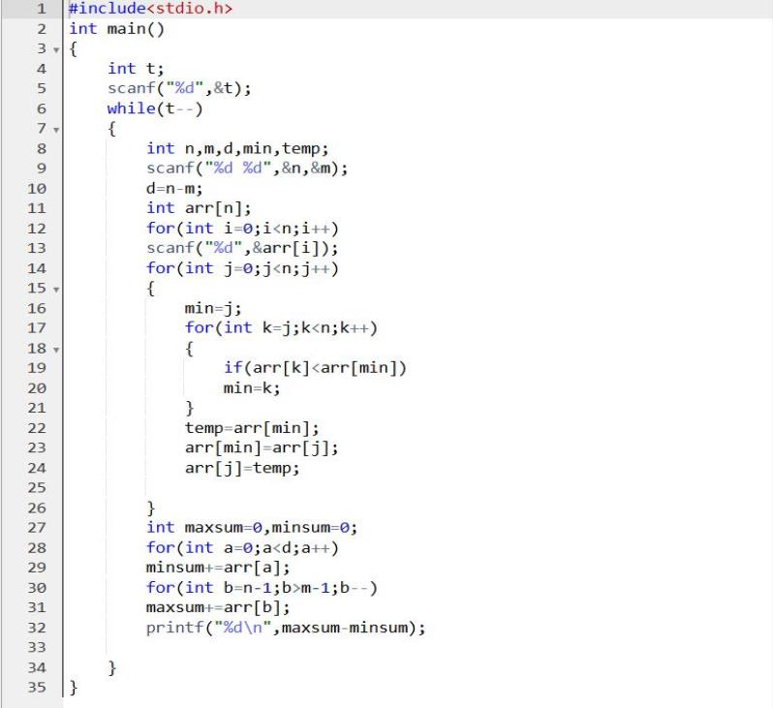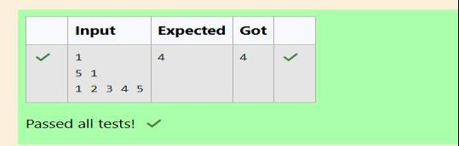

No

SAMPLE OUTPUT

100 328 248 689 200

123 146 454 542 456

5

SAMPLE INPUT

Strength of vaccines and midichlorians count of paents t in integer.

1 < N < 10

Input Constraint

Print a single line containing 'Yes' or 'No'.

Output Format

midichlorians count of paents.

which are strength of vaccines. Third line contains N integers, which are

First line contains the number of vaccines - N. Second line contains N integers,

Input Format

and paents are equal.

doctor can save all paents with the vaccines he has. The number of vaccines

vaccine doctor has and their midichlorians count. You need to determine if

which contains midichlorians count of each infected paent, Practo stores all

than midichlorians count of person. A doctor receives a new set of report

count. A person is cured only if midichlorians count in vaccine batch is more

produced from this virus has various strength depending on midichlorians

has discovered a new strain of virus which can cure this disease. Vaccine

A new deadly virus has infected large populaon of a planet. A brilliant scienst

Queson 2

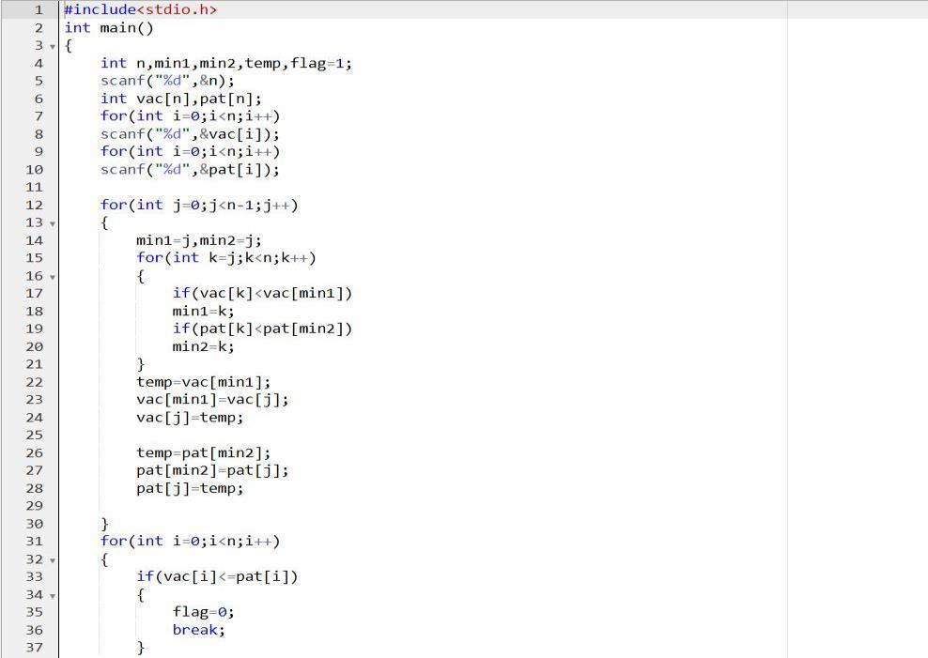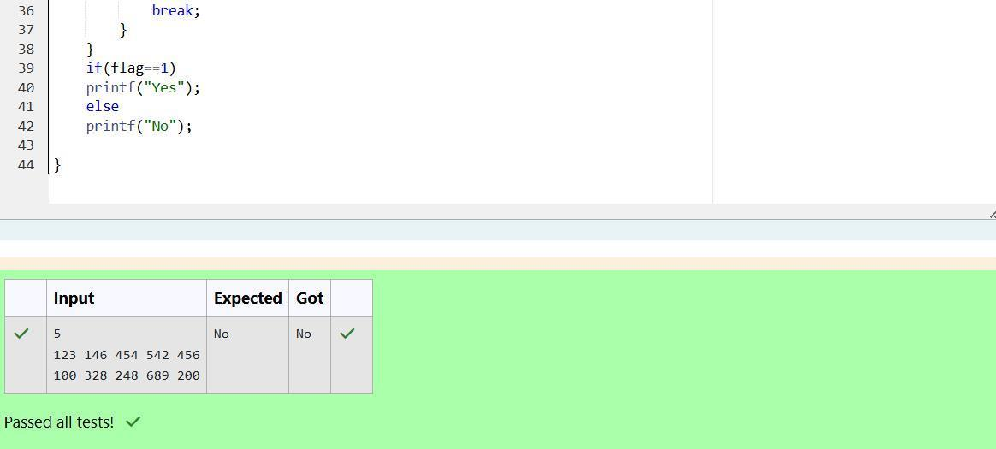

The 2 pair of indices are (1, 3) and (2,5)

Explanaon

2

SAMPLE OUTPUT

1 3 1 4 3

5

SAMPLE INPUT

1 ≤ ai ≤ 109

1 ≤ n ≤ 106

Constraints

Output the required number of pairs.

Output format

Second line: n space separated integers a1, a2, . . . , an.

First line: n denong the number of array elements-

Input format –

0.

the number of pair of indices (i, j) such that 1 ≤ i < j ≤ n and ai xor aj =

You are given an array of n integer numbers a1, a2, . . . , an. Calculate

Queson 3

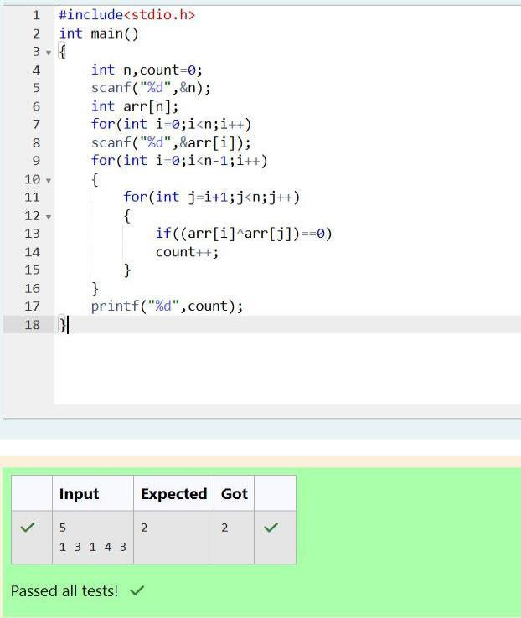

4 2 0 1 3

SAMPLE OUTPUT

4 5 3 7 1

5

SAMPLE INPUT

NOTE: The indexing of the array starts with 0.

0<=A[i]<=106

1<=m<=106

CONSTRAINTS:

Output consists of a single line of integers

OUTPUT :

The next line consists of the array of size m

The rst line of input consists of the size of the array

INPUT :

output should be "4 2 0 1 3"

Aer sorng the new array becomes A={1,3,4,5,7}. The required

Example: A={4,5,3,7,1}

indices of the new sorted array.

is to sort the array in non-decreasing order and print out the original

You are given an array A of non-negave integers of size m. Your task

Queson 4

